Canvas LMS - QuickStart Guide 4 PGCC Faculty and Staff

Table of Contents

1. How to login and logout of the Canvas LMS? 1
2. Canvas Training Options for Faculty and Staff 2
3. Accessing Canvas self-paced training courses 4
4. Getting Help - Canvas Support Options 6

How to login and logout of the Canvas LMS?

Logging In: Go to the myPGCC portal (my.pgcc.edu) and enter your PGCC Username & Password.
After logging in, look for the Canvas Icon under the title Faculty & Staff Portal, and click to access the Canvas LMS Site. It should automatically take you to the Canvas Dashboard!
Logging Out: From the Canvas Global Navigation Menu Select Account -> Logout
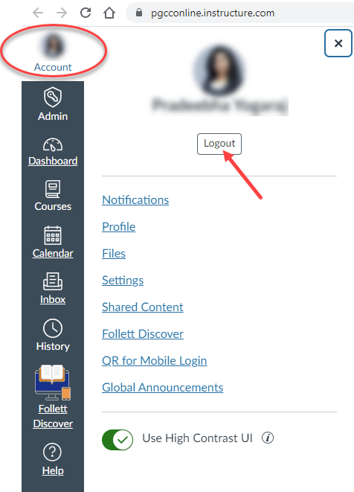

Canvas Training Options for Faculty and Staff

For PGCC Faculty and Administrators, Canvas offers a variety of training options under the Canvas Training Portal. The Learning Library contains all available training contents separated into learning experiences:
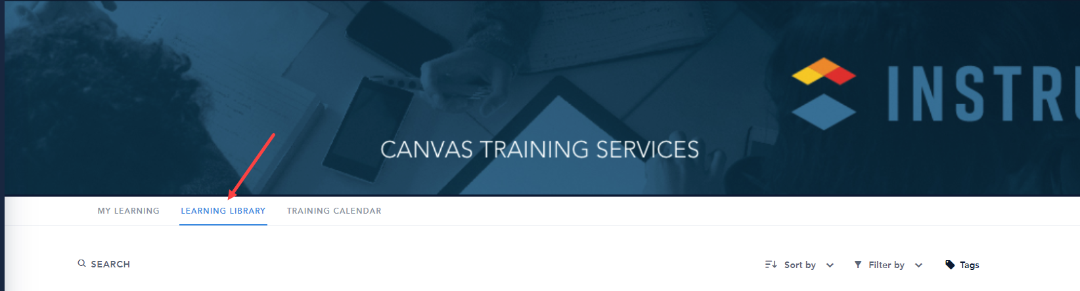
- Learning Pathways – These are a group of theme-based coursed (self-paced)
- Courses – a self-paced course that focuses on a specific Canvas skill or practice
- Videos – contain trainer tips and How-to training videos
- Live Webinars with Canvas Trainers

The following steps show how to access the Training Services Portal to Register/Unregister for Canvas Live Webinars with Canvas Trainers:
After logging into Canvas Portal -> Click on the Help icon from the Global Navigation Menu.  Select Training Services Portal option  Click on the Training Services Portal  Then in the next window click on the link Training Services Portal – Enter here! | 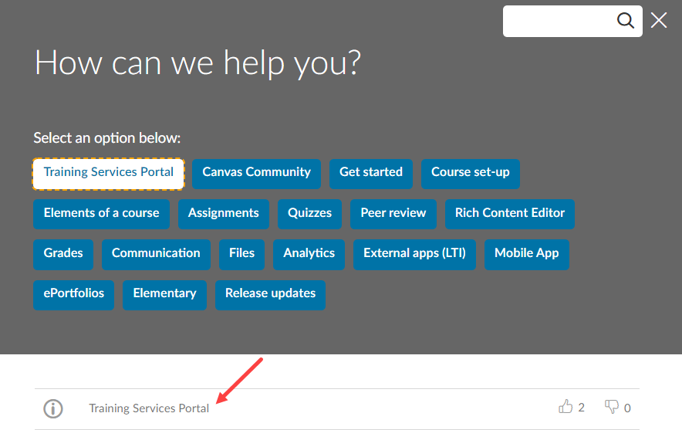  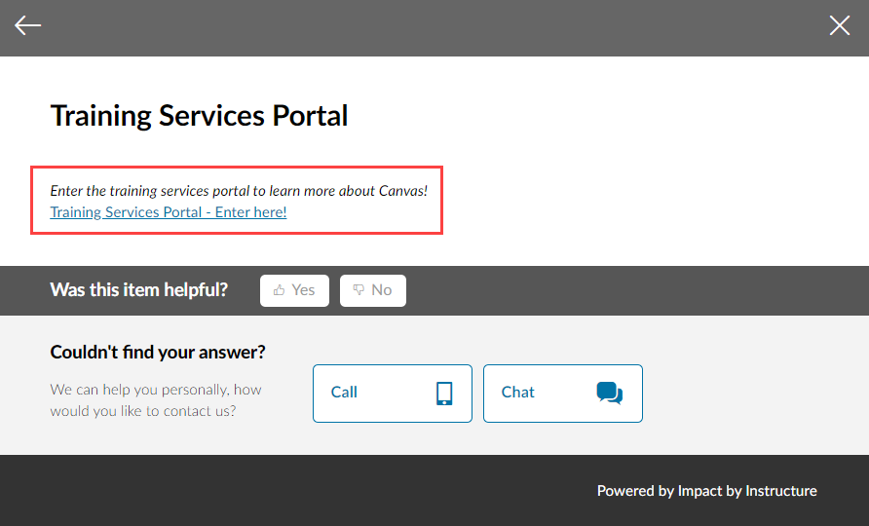
If prompted with the screen shown, select Authorize to access the Training Portal.  Go through the Canvas Training Portal Tutorial then on the last screen check the box that says “Don’t show again.” Then, click on Complete and Close the Canvas Training Portal Tutorial Window by clicking on the X on the top right-hand side of the window.  If shown, click on the green Launch Training button. Note: Launch Training option will not show for all users. If not shown go to the next step. | 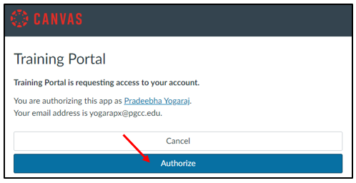
From the horizontal menu bar, select the Training Calendar option to view all the courses (webinars) offered by Canvas Trainers. | 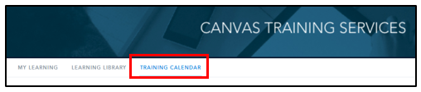
Select more to view all the classes offered on a particular day or switch from Month View to Agenda View to see all classes all at once.  Click on the course if interested and select REGISTER. Note: As soon as you register for a course, you will receive a confirmation email from Canvas Training Services. Also, the course will be highlighted in green on your Canvas Training Calendar. | 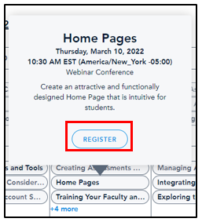
The email notification will contain an attachment as shown. Click on the down arrow to open. Then select yes to add the event to your calendar. Make sure to set the Reminder for the event and click Save. Now the event is added to the Outlook Calendar successfully! | 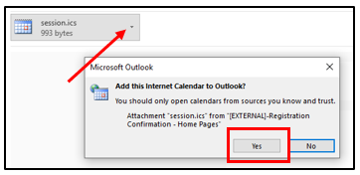
If for any reason you are unable to attend the course, please click on the course and select UNREGISTER.  Note: You will NOT receive a confirmation email and also you have to delete the event from your personal calendar. | 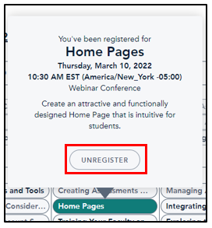

Accessing Canvas self-paced training courses

To enhance student learning and your classroom experience please utilize the following self-paced courses.
The following steps show how to access Higher Education: First Day Ready course, Growing with Canvas (Teacher Training) course, and username-Test-Course (Sandbox Course).
Accessing Higher Education: First Day Ready  After logging into Canvas Portal -> Click on the Help icon from the Global Navigation Menu.  Select Training Services Portal.  Select Authorize on the Training Portal window if prompted. Also, close the Canvas Training Portal Tutorial Window by clicking on the X on the top right-hand side of the window. Then, click on the green Launch Training button if it is shown.  From the horizontal menu bar, select the Learning Library  In the search field type “higher education: first day ready”  Then click on the image under the category: Higher Ed Programs – Instructors and Support Staff (Higher Education: First Day Ready) and click Enroll to register for the class. Find the class under the My Learning tab to Start the course. | 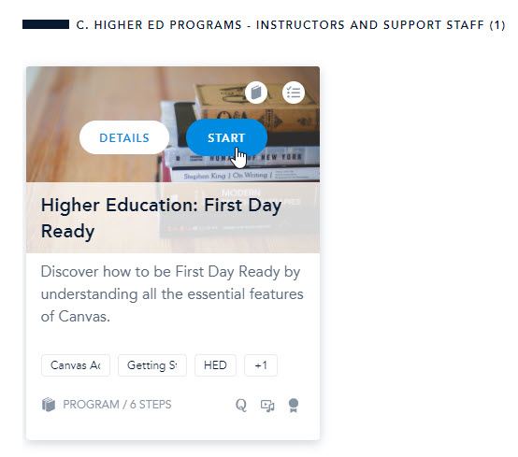  NOTE: There are multiple courses with similar names therefore, select the course under the category: Higher Ed Programs – Instructors and Support Staff
Accessing Growing with Canvas (Teacher Training) course & username-Test-Course (Sandbox Course).  These courses should be automatically populated under the Dashboard section of the Canvas account as shown in the image.  Click on each image to access them.  Note: The username-Test-Course is an empty shell. This course is provided to you for testing/learning purposes. | 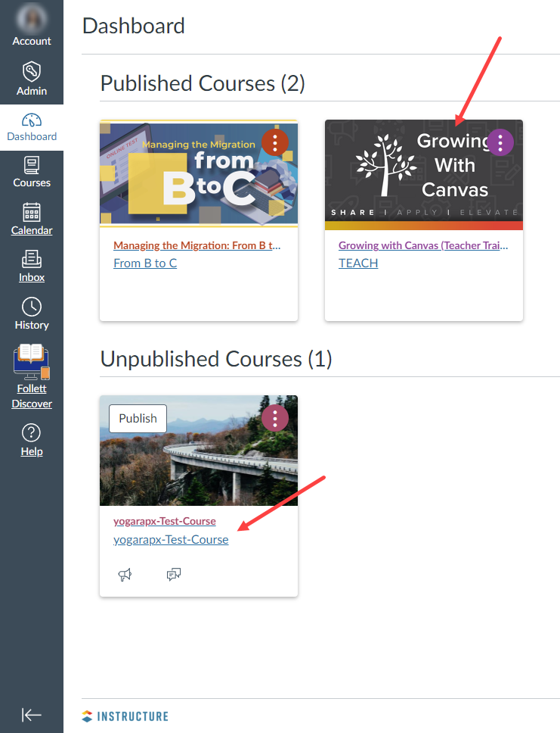

Getting Help - Canvas Support Options

eLearning Services is proud to announce that with our transition to the Canvas learning management system comes 24/7 Tier 1 Canvas support. This affords all PGCC faculty, staff, and students access to technical assistance for any Canvas-related issues or requests. Having difficulty with a link? Can’t find a particular course or feature? Not sure how to perform a specific task? Simply reach out to Tier 1 Canvas support for assistance at any time of the day on any day of the week!

The following steps show how to make use of self-help content and get in touch with 24/7 Tier 1 Canvas Support:
After logging into Canvas Portal  Click on the Help icon from the Global Navigation Menu.  The eLearning Support Center window will display in the center of your screen. To access self-help articles and videos, click on a topic you need assistance with within the top portion of the window. Then select from the suggested support content in the bottom portion. | 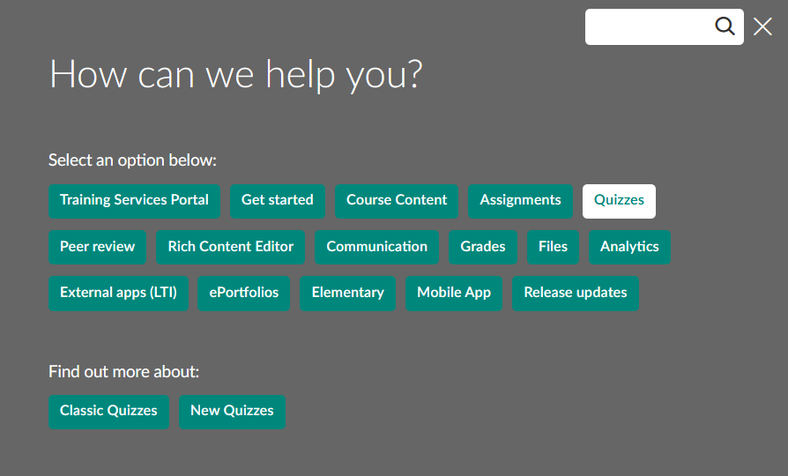  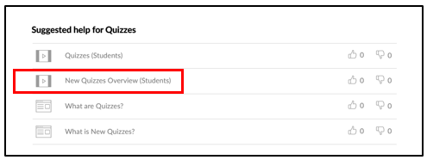
If the suggested support content does not fully address your issue, you can contact Tier 1 Support using the Call or Chat buttons at the bottom of the Support Center window. Note: If you don’t see these buttons scroll down. | 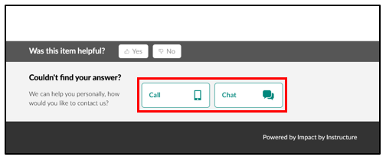
Clicking the Call button will route you to the Contact Call screen. Click the Reveal phone number and reference tab to display the phone number to Canvas Support and a unique reference number to provide the live agent. | 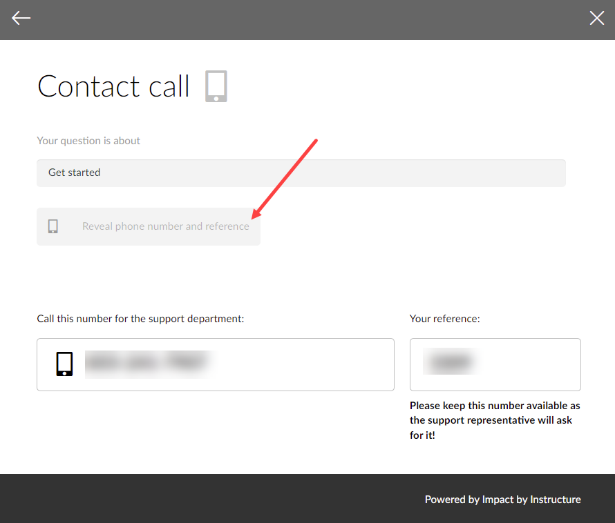
Conversely, clicking the Chat button will route you to a chat initiation page. Be sure to fill out the form in its entirety with your first and last name, email address, a brief description of the issue as the subject, and your role.  After completing the form, click the Start Chatting button at the bottom. | 